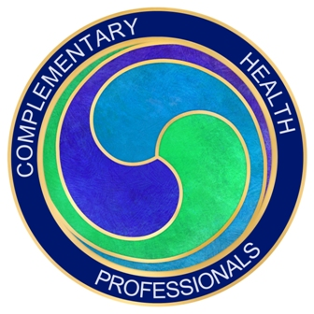
Complementary Health Professionals
Annual Conference and Awards Ceremony Agenda - 29th October 2016

We are delighted to be able to invite you to our first annual conference following the merger of the Aromatherapy & Allied Practitioners' Association and the British Neuroskeletal Re-alignment Therapy Association in September 2015. We are pleased to announce that Joyce and Lawrence West will be attending the conference as honorary guests to give the Awards. We trust that you will enjoy what we have organised for you and remember that you will receive 6 CPD points for attendance.
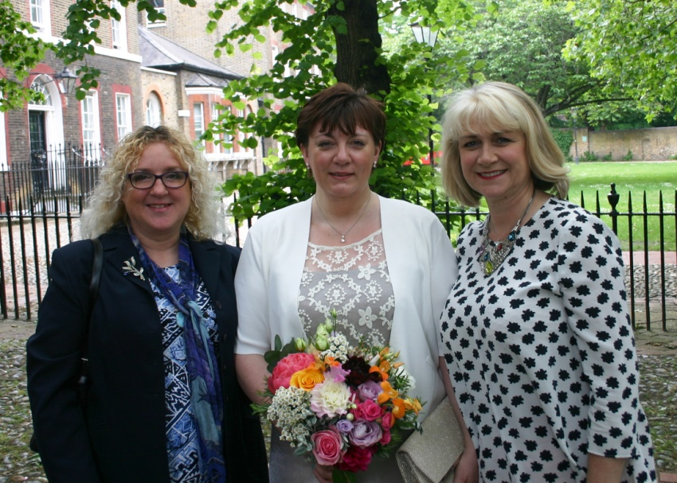
Carole Preen, Julia Oyeleye and Julie Quinn, Directors of Complementary Health Professionals at Julia's wedding earlier this year.

9.30 Registration and coffee, flapjacks, fruit
10.00 CHP Welcome and Do-In exercise for energy and invigoration!
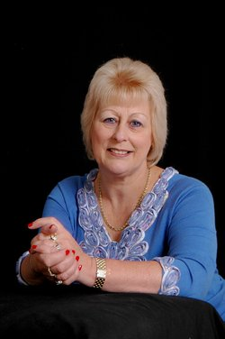
10.30 Denise Tiran, Educational Director, Expectancy
“Working with Pregnant Clients - integrating complementary therapies with conventional maternity care”
Author of Clinical Aromatherapy for Pregnancy and Childbirth, Denise, a qualified midwife is regarded internationally as the leading authority on complementary therapies for pregnant women. Denise is also offering a book signing following the release of the second edition of her book.

11.15 Break
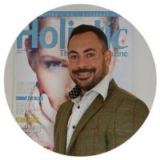
11.30 Jayson Firmager & Vicky Killick - Founders, Holistic Therapy Magazine - "Enhance your business success "
The magazine, given free electronically to CHP members, is the first UK magazine to cater for professional therapists who wish to keep up with industry news as well as develop their business skills in a competitive industry.Jayson and Vicky will be giving you some advice to help you enhance your business success.
12.15 Urban Massage - information on jobs available
12.30 CHP Annual Awards Ceremony
13.00 Lunch Break
14.00 Emma Lane ND - Owner, Integrative Health Education, Naturopathic Nutritionist, Functional Medicine Practitioner - "Tells of the Dis-eased Body"
Emma Lane is the founder and director of the Lane Wellness Group which includes the training organisation Integrative Health Education and her practice Energize Mind Body. She is recognised as one of the UK’s leading holistic health and lifestyle experts and has trained extensively in Europe and America. Her expertise in gastrointestinal health and pathogens led Emma to be chosen as the European distributor for the Parasitology Centre Inc., the most renowned, respected and accurate parasitology lab in the world.
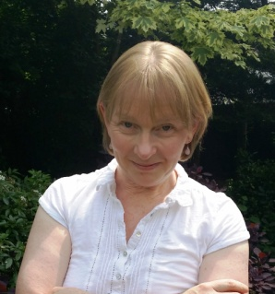
Can you spot the early warning signs that indicate the body is out of balance and heading for ill health? For example, did you know that a prominent diagonal crease on the ear lobe is associated with coronary heart disease? During this session you will learn valuable naturopathic ways to recognise and interpret the body's early warning system and help clients avoid significant health problems. Take away tools that can be put to use by complementary health professionals in their practices.
15.30 Sarah Yow - Director, Routes to Healing - Inner Energy Healing
"A new perspective on Chirokinetic Therapy"
Sarah is the co-founder of Routes to Healing in Cambridge along with Caroline Prudames, which is a CHP accredited college. Sarah has been practising complementary therapies since 1999 and teaching since 2003 following her career in Social Services with clients who had serious needs. After studying CKT, she has further developed the theory and practice into Inner Energy Healing, which is an amazing technique that can get right to the causal root of any problem and now has a large practice with hundreds of success stories. Come and find out more about the therapy and take some new information home with you.
16.00 Plenary and Chakra Balance Meditation
16.30 Collect CPD certificates and End of conference

