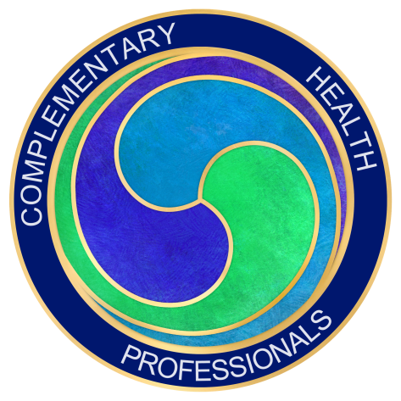
Complementary Health Professionals
Annual Awards 2016

To be presented at the CHP Annual Conference on 29th October 2016 by Joyce and Lawrence West, former AAPA Chair and Secretary.
Entry criteria are that you are a premier, basic or student member of CHP. You will receive a certificate and electronic stamp to place on your marketing. Is this your year to stand out?
Categories
1. Best CAM Clinic or Business of the Year
This award will be given to someone who has developed an excellent business or complementary therapy service with innovative thinking that serves their clients. It will demonstrate excellence in business skills with an innovative website. It might include the opportunity to employ others within that business or may just be a really great example of a successful and thriving business.
2. Student of the Year
This award will be given to a student who is out of the ordinary. They will be nominated by their tutor or peers and will have demonstrated passion for their subject, and produced excellent coursework. They may have had to overcome extraordinary odds in order to keep on course or just have been highly motivated and dedicated to becoming the best therapist possible.
3. Complementary Health Professional of the Year
This award will be given to the complementary therapist who has demonstrated excellence in their practice. This could be through excellent client service where clients feel that their therapist has gone above and beyond in terms of quality service and outcomes for their treatments. It might also be related to a member who has conducted some innovative research that has benefited the CAM community. It could also be awarded where a therapist has developed a therapy or someone who has inspired others through sharing information in therapy groups or by volunteering their services.
How to enter
You will find the nomination form on by clicking here

